Web 2.0 Postal Enterprise Software framework

Overview
A BPM driven Collaborative Event and Transaction framework. A Multi-tier Web 2.0 platform for Enterprise deployment across the Web and Desktop environments both in-house and for the post office’s small and medium sized business customers. Running on Windows, Mac and Linux operating systems or any combination, it includes integrated CRM, Help Desk support, Enterprise IM & remote management.

Built on Flash and utilising the XMPP protocol to link all the enterprise nodes in real time, the framework has built-in support for long term disconnected operation with automatic synchronisation and a state engine based UI to support the different operating models on Workstations, PDAs, Kiosks, Phones and the Web.

First implementation
The first implementation of the framework will be as a front end to the mail enrolment device which will be able to run as an embedded web device or as a standalone software component interfacing to the enrolment device in a manner similar to a device driver.

Device Interfaces
This implementation will provide both a web interface to the device and a web service interface enabling the device to be queried directly by standard postal software running on a counter, kiosk or workstation or be “browsed” from a PC connected to the same network.

These two interfaces will provide the same “business” functionality, i.e. both will provide a means to enrol mail items and facilities for setup, configuration and access to maintenance logs etc.

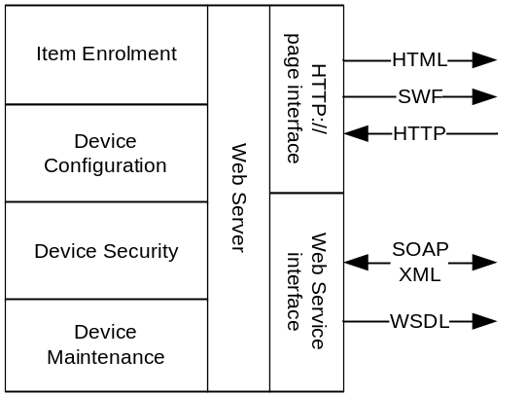

When accessing the device via web services, it will act just as any other peripheral would; returning the pertinent information based upon queries from the host. This will be achieved using SOAP XML messaging and will be fully extensible as new capabilities are added to the device.

User interface
When accessing the device via HTTP using a browser over the local network, the device will present a highly intuitive, graphically rich user interface designed to provide the quickest means of enrolling an item with the highest accuracy. Based upon the information collected from the mail item, the system will establish the quality of service required and only present valid primary services with their associated secondary services; it will then lead the operator through the process of selecting the remaining parameters in the most instinctive way possible.

At any point in the process of assessing a mail item, the system will present the most appropriate services to the operator. The parameters examined to assess the suitability of a service will depend on factors such as Weight, Destination (or distance) Size, Delivery Date, Customer Type, Payment limitations, Current promotions, Suitability of Contents and Quantity of items.

Assessment
In addition to providing the most appropriate services, the system will calculate the appropriate fees, taxes and discounts and display these to the operator. The system will be able to generate the delivery point POSTNET or OneCode code at the point of enrolment and will also be able to base fees for insurance etc. on the delivery point suitability if available.

Once a mail item has been enrolled, all the related information that has either been collected from the device or the operator, including a digitally signed image of the item, the OCR data, any Barcode information and all the information regarding the time, place of enrolment and operator id will be collected for transactional integrity and future monitoring and analysis.

Demonstration
A demonstration of the fundamental elements of the device and interface software will be provided; this will consist of a representative set of mail items being presented to the device for enrolment and the appropriate behaviour being observed. The mail items chosen for this demonstration will be:

A standard letter
The letter will be placed upon the device and the software will provide the appropriate fee based upon the size, weight and destination. All the information collected regarding the item will be recorded and available for display.

An oversized letter
The letter will be placed upon the device and the software will provide the appropriate increased fee based upon the increased size, weight and destination. All the information collected regarding the item will be recorded and available for display.

A transparent packet containing medication
Again the item will be placed upon the device and the software will provide the appropriate fee based upon the size, weight and destination. All the information collected regarding the item will be recorded and available for display, this will include a digitally signed image of the original item and its condition at the point of enrolment.

A parcel
The parcel will be placed upon the device and the software will provide the appropriate fee based upon the dimensions, weight and destination. All the information collected regarding the item will be recorded and available for display, this will include the dimensions of the parcel.

Full system
Once the demonstration is complete, a deployable pilot prototype will be developed featuring enterprise reporting/charting, distributed management and control, fully featured development tools and different User Interface paradigms for Kiosks etc.

